|  |  |
| --- | --- |
| **Network Infrastructure**  Diploma in CSF / IT  Year 2 (2020/21) Semester 3 | Week 03 |
| Tutorial |
| IP Routing (Static Routing) | |

**OBJECTIVES**

After completing this session, you should understand the concepts of routing and static routing.

**Activity 1**

1. How does the network layer forward packets from the source to the destination?
   1. by using ARP responses
   2. by using an IP routing table
   3. by referring to a name server
   4. by referring to the MAC address table (switch table)
2. ________ is a network with one path to a router.
   1. Static network
   2. Dynamic network
   3. Local area network
   4. Stub network
3. Which best describes a default route in the routing table of a router?
   1. urgent-data route manually entered by a network administrator
   2. route used when part of the network fails
   3. route used when destination network is not listed explicitly in the routing table
   4. preset shortest path
4. What role does the network ID play in an IP address?
   1. it specifies which networks the device can communicate with
   2. it specifies which node on the subnetwork is being addressed.
   3. It specifies the identity of the computer on the network
   4. It specifies the network to which the host belongs
5. Routers use _________________ to forward traffic through a network.
   1. IP address
   2. IP address and MAC address
   3. host address and MAC address
   4. MAC address
6. In order to automatically build a routing table, the router must use
   1. static routing
   2. default routing
   3. stub routing
   4. dynamic routing
7. Which of the following statements best represent the advantage of a static route?
   1. better control
   2. flexibility
   3. ease of management
   4. manual entry
8. The router must read the ___________ in the IP header to decide where to direct an incoming packet.
   1. source address
   2. destination address
   3. flags
   4. TTL
9. Which IP header field is used to control packets that might otherwise loop endlessly through a network?
   1. source address
   2. destination address
   3. flags
   4. TTL

**Activity 2: Routing**

1. What is the function of a router? Compare the function of a router with a switch.

|  |
| --- |
| The function of a router is to forward packets to destination and act as an intersection between multiple network. Compare to a switch, router also allow all devices among multiple network to see all IP address in the network which switch cannot do. |

1. Describe the advantages of using a router.

|  |
| --- |
| * Separates network logically into subnets; reduces network traffic as packets are only routed to their destination subnet * Isolates MAC broadcasts as it does not forward broadcast frames. * Connects different protocols: LAN protocols (e.g. Ethernet MAC) and WAN protocols (e.g. PPP). |

1. How does a router create entries in its routing table? What is the typical information in the routing table? Briefly explain how a router makes routing decisions using its routing table.

|  |
| --- |
| A router can create entries using static route where user need to manually configure or dynamic route where it advertises to the nearby device to get network information to build its own routing table. In the routing table, it has network destination address, network mask, gateway, interface and metric. The routing decision is make using metrics and prefix length in the routing table to find the shortest, administrative distance from ip route is also use to determine the best route. |

1. Based on Figure 1 below, explain how a data packet is routed from PC A to PC B.

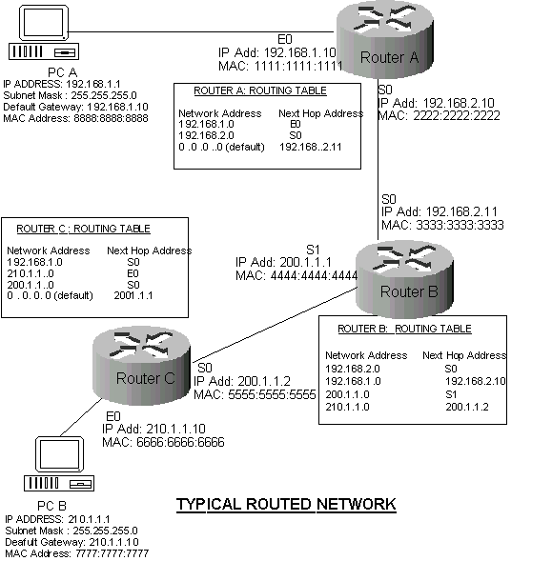

**Figure 1:** Routing in a typical network

|  |
| --- |
| PCA will send a data packet to Router A E0 interface. Router A will look at the destination IP address in the packet IP header and try to match it routing table. Router A did not find the destination IP address, so it will broadcast to nearby router, which is router B to check if router B routing table have the IP address. If no, router B will broadcast to Router C to check, which have the destination IP address. Therefore router A will forward to the packet to Router B than Router B will forward to Router C and forward to PC B and PC B will send a packet back to say it received the packet |

**Activity 3: Static Routing**

1. Give two advantages and one disadvantage of static routes.

|  |
| --- |
| Advantage  • Static routes are not advertised over the network, resulting in better security.  • Static routes use less bandwidth than dynamic routing protocols, no CPU cycles are used to calculate and communicate routes.  Disadvantage  • Need to reconfigure all router in the network if any change is done to the network |

2. Figure 2 below shows a typical corporate network with 4 routers. To reduce routing overheads, the network administrator decided to use static routing.

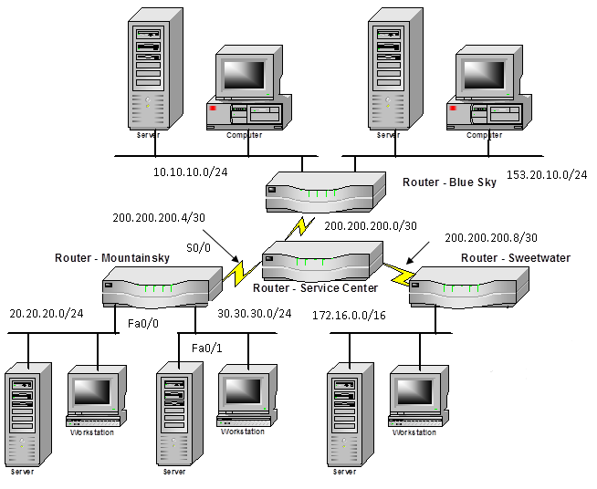

Figure 2: Typical corporate network

a) Write down the commands to configure the Mountainsky router with the IP addresses of all its interfaces. All the Mountainsky router interfaces are assigned the first usable address of their subnets.

|  |
| --- |
| Mountainsky(config)# int Serial0/3/0  Mountainsky(config-if)# ip address 200.200.200.5 255.255.255.252  Mountainsky(config-if)# no shut  Mountainsky(config-if)# int fa0/0  Mountainsky(config-if)# ip address 20.20.20.1 255.255.255.0  Mountainsky(config-if)# no shut  Mountainsky(config-if)# int fa0/1  Mountainsky(config-if)# ip address 30.30.30.1 255.255.255.0  Mountainsky(config-if)# no shut |

b) Write down the commands to configure the Mountainsky router to create a static route for each of the remote network in the company. The IP address of the next hop router is 200.200.200.6.

|  |
| --- |
| Method 1: Using out-going Interface  Mountainsky(config)# ip route 200.200.200.0 255.255.255.252 s0/3/0  Mountainsky(config)# ip route 200.200.200.8 255.255.255.252 s0/3/0  Mountainsky(config)# ip route 10.10.10.0 255.255.255.0 s0/3/0  Mountainsky(config)# ip route 153.20.10.0 255.255.255.0 s0/3/0  Mountainsky(config)# ip route 172.16.0.0 255.255.0.0 s0/3/0  Method 2: Using the Next Hop Address  Mountainsky(config)# ip route 200.200.200.0 255.255.255.252 200.200.200.6  Mountainsky(config)# ip route 200.200.200.8 255.255.255.252 200.200.200.6  Mountainsky(config)# ip route 10.10.10.0 255.255.255.0 200.200.200.6  Mountainsky(config)# ip route 153.20.10.0 255.255.255.0 200.200.200.6  Mountainsky(config)# ip route 172.16.0.0 255.255.0.0 200.200.200.6 |

c) Since Mountainsky router is part of a stub network, write down the one command required to configure the Mountainsky router to enable the 20.20.20.0/24 and the 30.30.30.0/24 networks to reach all the networks in the company. The IP address of the next hop router is 200.200.200.6.

|  |
| --- |
| Mountainsky(config)# ip route 0.0.0.0 0.0.0.0 200.200.200.6 |

d) Write down one command required to configure the Service Center router to enable the 20.20.20.0/24 network to be reachable by all the networks in the company. The IP address of the Mountainsky router is 200.200.200.5.

|  |
| --- |
| Service Centre(config)# ip route 20.20.20.0 255.255.255.0 se0/2/1 |